PromÉthÉe, a Collaborative tool for a more effective Facility management process

Abstract
The last two decades, due to fierce competitions, organizations have decided to refocus on their core business by outsourcing some of their internal activities or services. These concern building maintenance, cleaning services, infrastructure improvement, catering or gardening. Facility Management (FM) as an emerging discipline is getting a lot of attention from practitioners in pursue of a more systematic integrated approach to operating, adapting and maintaining infrastructure. This paper introduces concepts and functions of an innovative system so-called PROMOTHÉE, aiming to enhance collaboration within the maintenance and operation building domain and amongst several involved stakeholders in a FM process.
Keywords: Facility management, Knowledge sharing, building maintenance and operation, Computer aided systems Facility Management (CAFM)
Introduction
Today, it is well recognised that in order to be able to increase competiveness of organisations, it is important to refocus on developing a working environment supporting their main business objectives (Mustapa & Adnan, 2008). Therefore, some companies have decided to outsource their secondary activities such as for i.e. building maintenance, cleaning services, securities to third parties in order to focus better on their core business. Today, many companies are facing the issue of people retirement; hence, with reduced work force, it is even more important to concentrate efforts on achieving the main business objectives. The last three decades, a new business segment, the so called “Facility Management (FM) has emerged as a profession encompassing multiple disciplines to ensure functions of the built environment by integrating people, place, process and technology (IFMA, 2014). FM contributes to spare organizational assets, time, staff and physical resources. In addition, FM as a customer centric activity offers quality and timely, integrated services. A well-designed FM strategy will contribute to create a more efficient working environment for both facility managers and their customers (Keane, 2011).
In 2009, a survey have been conducted in 62 countries by global job task analysis (GJTA). The study intended to gather the core competencies needed in a facility management effort (GJTA, 2009). They are listed below:
- Communication—Communication plans and processes for both internal and external stakeholders
- Emergency Preparedness and Business Continuity—Emergency and risk management plans and procedures
- Environmental Stewardship and Sustainability—Sustainable management of built and natural environments
- Finance & Business—Strategic plans, budgets, financial analyses, procurement
- Human Factors—Healthful and save environment, security, FM employee development
- Leadership and Strategy—Strategic planning, organize, staff and lead organization
- Operations and Maintenance—Building operations and maintenance, occupant services
- Project Management—Oversight and management of all projects and related contracts
- Quality—Best practices, process improvements, audits and measurements
- Real Estate and Property Management—Real estate planning, acquisition and disposition
- Technology—Facility management technology, workplace management systems

One the most important challenges in conducting a successful facility management effort concerns the development of adequate technology or systems that could fulfil the requirements stated by the international Facility Management Association (IFMA): “how to best coordinate, the people and the work of an organization into the physical workplace” (Mustapa & Adnan, 2008). Facility Management have been well implemented in US, While, in Europe and in France in particular, it is still in the early phase. In France, the FM market is gaining an increasing attention from companies motivated by the need to decrease costs, economic crisis, retirement of high number of people and so forth. However, even though, systematic approaches and methods have emerged in order to standardize overall landscape of Facility Management, it is as well recognized that the progression is still slow due to various issues. It is crucial to provide to organizations that outsource real estate services like cleaning, or, building maintenance, energy management, and so forth, knowledge about the status of various outsourced activities. Knowledge about the status of operations or maintenance activity is an important asset. Hence sharing knowledge amongst the stakeholders is vital. Stakeholders can be contractors, real estate owners, Facility manager, end users, artisans or craftsman. One issue that could hamper the knowledge sharing process is related to poor technological infrastructure promoting in more effective way cooperation between different actors involved in a facility management effort (Brejon, 2014). In order to increase knowledge sharing, it is important to provide an online platform enhancing the collaboration between different stakeholders. Several companies claim that they are providing software for Facility Management the so called “Computer Aided Facility Management (CAFM)” (SoftwareAdvice, 2015). Most of them provide clear support for strategic operations. In addition, large amount of generated data contributes to help the FM managers to provide an overall view of the Current FM Process to their customers. A relationship is established throughout the Service level agreements (SLA) and key performance indicators (KPI) sharing (Keane, 2011). In addition, CAFM software might address planning of space, facilities, services and budgets However, most of the current CAFM are rather software helping to manage assets, or to track operation and maintenance of the buildings. Cooperation and collaboration issues amongst the stakeholders such as customers, FM managers, and third parties (artisans, users, ect..) are not sufficiently addressed.
This paper present an innovative platform enhancing collaboration between actors in FM process. This platform, so-called “PROMETHÉE” is based on cloud computing. The next section presents a brief overview of knowledge sharing and how cloud-computing concepts can be used to develop a collaborative platform for Facility Management. The third section outline the basic functions of PROMETHÉE.

Knowledege and FacilitY Management in cloud computing setting
Facility Management constitutes a real estate segment, where knowledge is considered as an important development asset. This business sector is facing various challenges ranging from real time maintenance or operational building, project cost reduction to environmental issues. In addition, it is not uncommon that each facility is managed by its stakeholders in isolation from the management of other similar facilities (Borgert, Munch, & Heuser, 2014).
Management of multiple geographically dispersed facilities including different stakeholders means that measures to take care of knowledge are crucial. Knowledge Industry management aims at improving the ability of firms to execute operational or maintenance functions in a more efficient and effective way. There is a general consensus on agreeing that there is so far no one single definition of knowledge (Boisot, 1998; Dixon, 2002). One popular definition is from Davenport & Prusak (2000), they define the knowledge as “a fluid mix of framed experience, values, contextual information and expert insight that provides a framework for evaluating and incorporating new experiences and information”. Hunter(1999) focuses more on actionable knowledge and suggests rather "Knowledge is information in the mind, in a context which allows it to be transformed into actions”.
Practitioners and academics have defined several types of knowledge such as tacit, implicit, explicit and systemic knowledge at both individual and organizational levels (King & Marks, 2008).
It is important to identify the type of knowledge, tacit or implicit, in order to adopt the adequate strategies for capturing, storing, sharing, searching and disseminating the knowledge in a more efficient way. The type of industrial knowledge that should flow in the firms will direct the needed KM strategies such as codification for explicit knowledge or personalization for tacit knowledge.
In Facility Management business, both type of knowledge need to be taken into account. Therefore, it is important to identify the activities that require a special attention. FM consulting business is often engaged in large duplication efforts (Robson, Norris, Lefrere, & Mason, 2003). For example, consultants are often involved in repetitive solutions finding process together with the clients or third parties. Therefore, new ways to work and interact with all the business stakeholders need to be re-designed in order to make sure that knowledge is reused. In this case, codification of the knowledge could contribute to facilitate the reuse of it. Amongst the knowledge processes, knowledge sharing is perceived as the most challenging one to promote within a facility management setting. Defining the best knowledge sharing strategy will contribute to foster a better collaborative environment.
Based on assessment of the FM work process that took place over several years, requirements for developing this collaborative platform have been defined. In addition, survey with users have been conducted. Analysis of the requirements, help us to define the technical specification of the collaborative platform. Its most important functions are listed below:
- to unify the management of multiple geographically dispersed facilities
- to monitor operational and maintenance building in transparent way for all stakeholders
- to facilitate and share decisional reporting related to intervention measures trough document management system
- to provide Facility management processes as services.
- to manage work contract in effective way between facility manager, contractors and companies involved in the process of repairing or operating services

Based on the requirements, a platform providing functions allowing document sharing, geo-localizations of building, service maintenance or operation reporting, decisional reporting, follow up of work maintenance, and so forth have been specified.
In addition, it is important to make this platform available for all stakeholders independently of time and location. Recent developments of advanced cloud environments have gained a tremendous attention from the Facility management business sector (Borgert et al., 2014; Chang Ho, Hyuck, Hae Sun, Heon Young, & Yong Woo, 2009).
Practitioner and academics started to realise the value of not owning computing resources but rather lease them based on their current needs. In testimony, the increasing number of cloud- computing research studies within many domain of applications. For instance, Lau et al proposed a cloud-based platform designed to support/manage a multitude of smart facilities in large building companies (Lau et al., 2013). The concept of cloud-computing relies on considering software, data or hardware as a service. The main advantages are reduction of managing cost computer infrastructure by making it available on cloud, availability of data from anywhere. The next section describes the modules of PROMÉTHÉE that should fulfil some of the listed requirements.
PROMETHEE
PROMÉTHÉE is an integrated online cloud based platform management system that provides to organisations an environment integrating business, operation and maintenance processes. It encompasses several modules allowing geo-location of the assets, work scheduling, monitoring of the progress in real time. It receives up to date information and process it in an effective manners while reducing the cost of duplicating information. It is possible to integrate photographs, drawing annotation in an online form filling process; hence analysis reducing time during the maintenance tracking for i.e. One important feature in computer aided Facility Management is the option to generate reports for day to day management activities. In order to facilitate the decision making, the received data is categorized and prioritised. This decision support module proves to be efficient for a better collaboration between different stakeholders. Others modules are as well included and are described below:
Building assessment Module
This module encompasses several tools such as Audit Management tool, Technical audit tool and Energy Audit Tool.
Audit Management Tool (AMT)
An integrated geographical information system is integrated and therefore, location of the building to operate or maintain will provide various information such ways to access to it. This module describes as well the type of the building private or public, residential or services sectors, its area, structure, technical equipment’s and their operational status
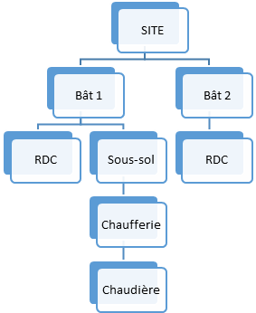

Figure 1: overview of the building level

The figure 1 depicts a site that have 2 buildings. The building 1 (Bât1) is composed of 1 level floor (RDC) and basement. In the basement, we can find a heating plant that is composed with a furnace.
Technical Audit Tool (TAT)
This module provide information about technical settings and list of operational and maintenance works to perform. The buildings assessment helps to define the health status of buildings and are categorized into four major areas such as:

- Safety of people and good: Risks that could impact safety of people or good should be identified, assessed and prioritized. Safety risks might be originated either by the installation of equipment’s or specified by safety regulation body. For example, a default on the electrical appliance might lead to a fire or electrocution risk.

- Work Maintenance: this area focuses on specific work description linked to corrective or evolutional maintenance of equipment fleets that are nearing the end of their operational lives or outdated such for i.e restoration of building’s historical facade. Another example includes, continues mechanical failures on boiler systems requiring extensive maintenance work means its replacement.

- Upgrading existing buildings: lead to identification of pathologies related to equipment or the built environment in order to decide strategical investment such cost reduction, operational function improvement or building decoration such stairway upgrading or installation of heating control system.
- Environmental : defines the strategical or economic measures having a beneficial effect on the environment such for i.e put in place an energy policy complying with EU regulation.

Currently the database of PROMÉTHÉE contains 25 000 entries, reports are automatically generated together with a diagnosis related document for each equipment and three pictures.

Energy Management Audit Tool (EMAT)

This tool provides preliminary information the so-called “ecological report” about the up to date building situation. It allows a snapshot of current energy consumption related to heating, water, power usage in common areas. This report allows improvement in order not only to reduce the cost but as well to control better the energy consumption. For i.e in France, since January 2012, all residential condominium unit with more than 50 district heating built before 2001, must complete energy audit within 5 years. Considering, the high number of buildings, it is important to provide functions that will facilitate this audit function.
Operation Management Module
This module encompasses several tools such as Metering Management Tool, Service Request Management Tool, Document management / report management, Maintenance Contract Management, Collaborative online Directories.

Metering Management Tool (MMT)
Optimization of fluid flow is essential in Utility and building management. Fluids are part of factors that contribute to the sustainability of building infrastructure. PROMÉTHÉE allows the follow up of various metering systems by collecting different data over several years period and analyse them. A set of data processing allows definition of some real and theoretical energy consumption and draws models in order to refine analysis. For Instance, energy consumption for the heating is associate to the ratio Mwh /DJU, thus efficient management will contribute to a better energy optimisation.

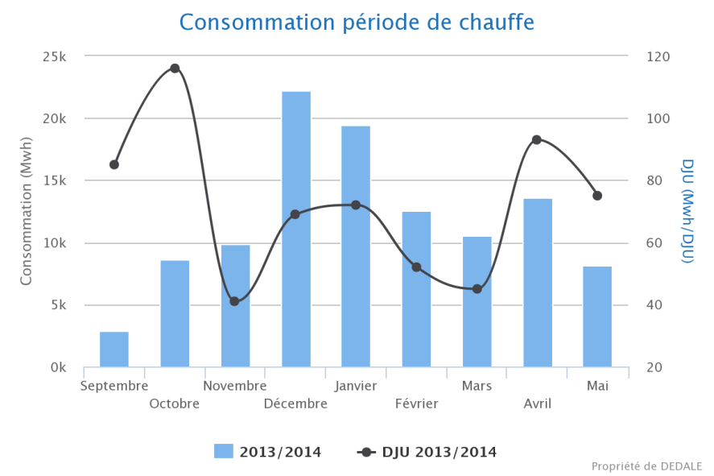
Figure 2: consumer profile

Services Request Management Tool
This tool aims to create, control and process all the services requests. The status of the service request is codified by specific code color that will allow the monitoring and the follow up. A report upon request is generated, can be utilised as the basis for the strategic maintenance. It is leads by tasks defining level of priorities of services to be executed. It allows optimisation of interaction between stakeholders such for i. e facility manager and the set of SME’s involved in the operation or maintenance process.

Work Follow up Tool (WFT)
This tool allows the follow up of any service request, from the diagnosis of the service until its closure. This service can be technical such as repairing a boiler or it can be tracking energy resources consumption for i.e.. Status of the monitoring the work underway is codified as well by a code color. During this activity, a report can be generated and contributes to provide the comprehensive set of data and analyses necessary to assess future investments or refine the maintenance policy. The figure 2 shows an example of generated report of diagnosis of heating system. A picture shows the machine and its external environment.

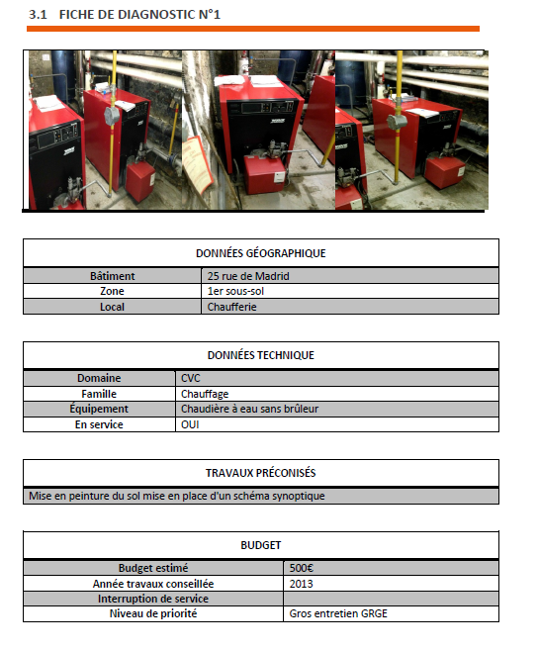

Figure 3: Work monitoring Report

Document Management System Tool (DMST)
Documents such Contracts, reports, invoices, plans, Geographical information, regulations, and so forth need to be stored, updated, removed and in some case shared amongst several people involved in the building facility management process. According to the type of documents, several categories have been specified and users according to his own profile and setting will get the views only into the documents that concerns them. Contractors, artisans and Facility manager cooperate in order to set up goals, objectives, resources and costs. This phase of discussions is documented trough several documents. Therefore tracking, updating these documents are essential. This module is considered to be the backbone of the FM process. Users and end users can access documents through web-based application. This provide a great flexibility for all the stakeholders as they can access to the document anywhere at any time. Security is of course, an essential requirement that is addressed through cloud computing features.

Contracts Management Tool (CMT)

This module offers user-friendly contract tracking, contract drafting, tasks, document management, workflows, document searching, reporting, and costing. This module contribute to help managers in their decision about maintenance policy.

Collaborative Directories Tool (CDT)
Sharing is essential for a succesfull FM process. Therefore, PROMOTHEE allows not only the sharing of the documents among several actors, but information about address, phone number, engineers, control units, and so forth are stored in database and it is easily accessible via a simple search function. Each actor is assigned to each building, hence facilitating the search of the relevant information and insure a level of good quality.
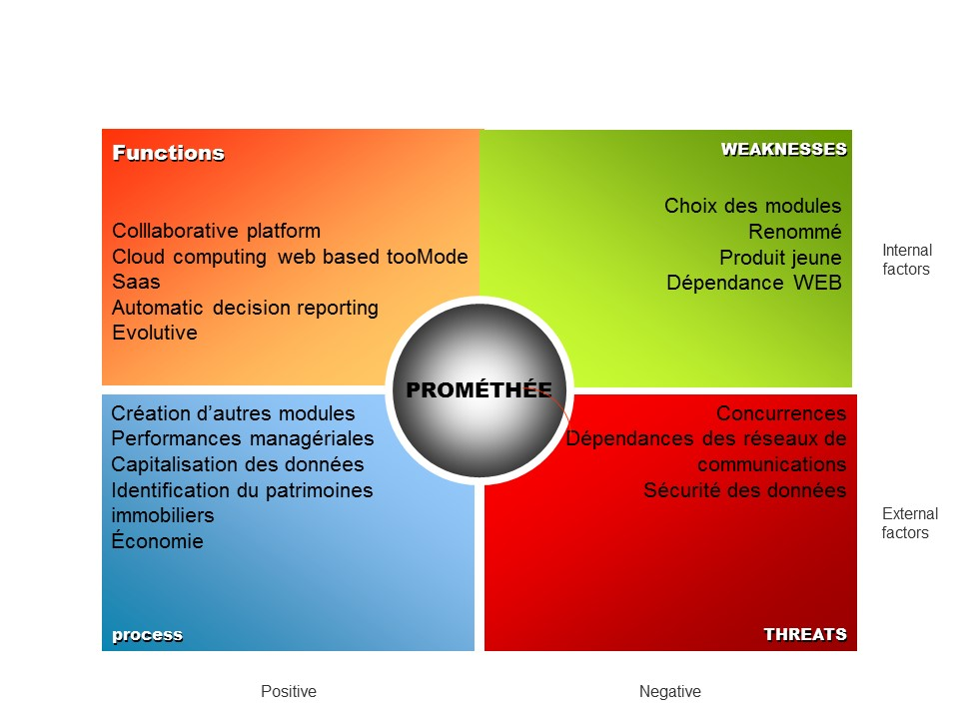
Figure 4: Benefits and Drawbacks
Conclusion
The FM’s role as a leader changed as the work environment has become more complex. In this paper, we described a tool PROMETHEE, that provides functions allowing management of several geographically dispersed facilities. The cloud-based platform provide flexibility for remote managers or operators. Future works include possibility to manage sensors that will be attached to the machines.

References

